Optical alignment equipment for experimental tests

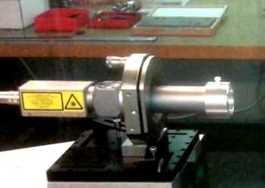

General information of the optical alignment equipment for experimental tests available:
- 3 vibration insulated optical tables.
- Different autocollimators:
  - NEWPORT LDS1000 (link) the LDS1000 electronic controller provides the means of displaying angular variations by measuring the movement of a spot of light on a position sensing device. General characteristics:
    - Digital resolution: 0.1 μm.
    - Measurement range: ±2000 μrad.
    - Measurement error: ± (1 ±0.02 x measurement.) μrad (i.e. ±2%).
    - Max. measuring noise: 0.02 μrad/√Hz.
    - Sampling frequency: 2000 Hz.
    - Digital integration: from 0.5 msec to 1 sec.

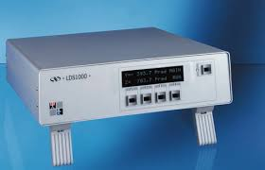

  - ZG Optique AE-025 (link): the Electronic Autocollimator AE-025 is equipped with a digital camera of high resolution and allows the precise measurement of an angle position of moving and stationary objects.General information:
    - Aperture: 40 mm.
    - Autocollimator field of view hor.(x) x vert. (y): 2700 × 2160 arcsec.
    - Resolution: 0.01 arcsec.
    - Repeatability: 0.05 arcsec.
    - Accuracy: 0.25 arcsec.
    - Interface: USB 2.0.
    - Sample frequency = ~ 10Hz
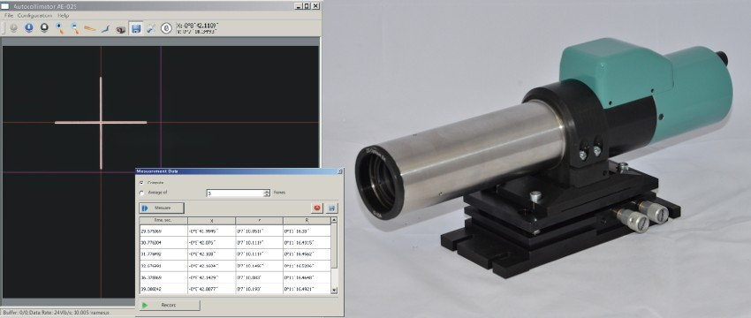

  - Others (WILD T2, Taylor Hobson, Lunette Leitz)
- FISBA OPTIK AG interferometer (link): digital Compact Interferometer µPhase 2 HR S/N 814.
  - Laser 632.8 nm.
  - Resolution 1000 x 1000.
  - Internal reference flat at lambda/100.
  - Natural beam size: 5 mm.
  - 2 available objectives:
    - 100 mm.
    - 150 mm.
  - Non coated reference flat lambda/10 rms.
  - Non coated reference sphere r=-10 mm lambda/20.
  - 2 Coated reference flat 125 mm diameter at lambda/10 and faces parallel below 0.1 arcsec.

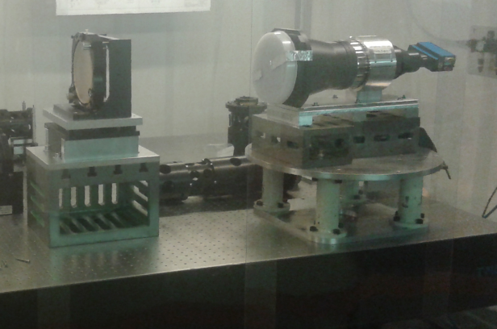

- Visible Spectrometer: Ocean Optics HR4000 (link). General characteristics:
  - Wavelength range: 200-1100 nm
  - Integration time: 4 milliseconds – 20 sec (continuous); 10 microseconds – 4 milliseconds (shutter)
  - Dynamic range: 3.4 x 106 (system); 1300:1 for single acqusition
  - Signal-to-noise ratio: 300:1 (at full signal)
  - Grating: H1 – H14; HC-1
  - Slit: 5 µm wide slits F#4
  - Optical resolution: ~0.2 nm FWHM

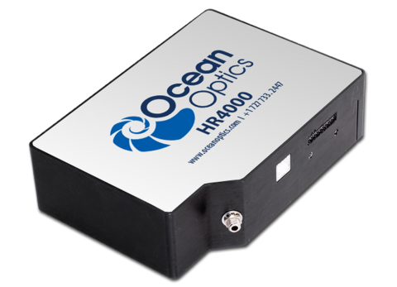

- Infrared Spectrograph: Yokogawa AQ6370C (link). General characteristics:
  - Wavelength range: 600 to 1700nm
  - High wavelength accuracy: ±0.01nm
  - High wavelength resolution: 0.02nm
  - Wide dynamic range: 78dB typ.
  - Wide level range: +20 to -90dBm.
  - Fast measurement: 0.2 sec. (100nm span).

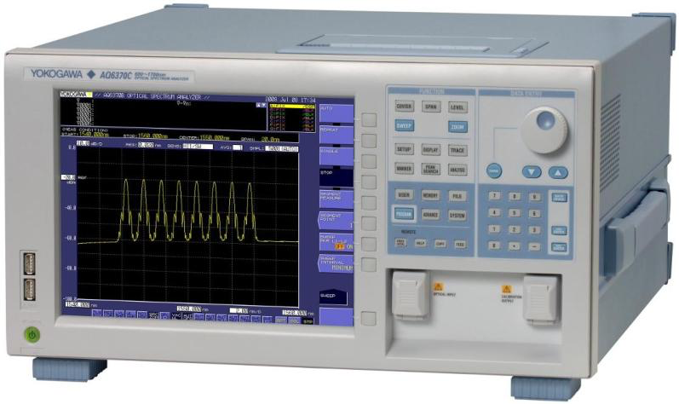
- Visible and Infrared cameras, and detectors.
- Visible and IR laser sources.
- Different ultra bright white light sources:
  - Model EQ-99-FC LDLS system (link) consists of a Power Supply Controller unit, Lamp House, laser fiber optic cable, and Lamp House signal cable.
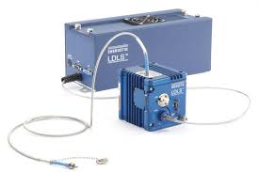
  - Supercontinuum White Light Source: LEUKOS – SM – OEM.

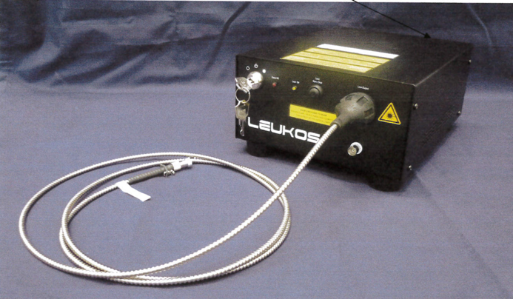

  - Others (HL-2000-FSHA lampe tungsten Ocean Optics, Laser Diode Thorlabs CPS192 780 nm, Diode laser Qphotonics QDFBLD-1550-5, etc)
- Integrating sphere: sphere of 280 mm of diameter in ODM98, from Gigahertz Optik (link). There are 2 FC fiber ports and an output port of 20 mm.

